《网页设计与制作》
课程设计报告

项 目 名 称： 教师信息管理系统
姓 名： 张丹玉
学 号： 41212205
班 级： 软件工程2班
日 期： 2015年 7 月 6 日

- 课程设计要求
教师信息管理系统

二、网站主要功能
采用Asp.Net MVC 5.0 + 简单三层架构 搭建的陕师大综合教务信息系统

数据库采用Microsoft Sql Server 2012 Enterprise

开发环境：Visual Studio 2015

系统功能：教师登录，密码修改，查看个人信息，修改个人信息，查看教授课程，查看学生成绩，资料下载，查看工资情况。

另外学生通道只有登录功能， 其余功能由于时间因素未完善。

界面设计：采用响应式设计，前台布局采用div + css 并使用了Boostrap框架

- 相关代码

项目架构组织：

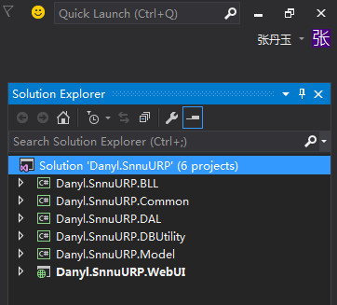

数据库连接字符串：

<appSettings>
<add key="ConnectionString" value="server=127.0.0.1;database=SNNUURPDB;uid=sa;pwd=123456"/>
<add key="webpages:Version" value="3.0.0.0" />
<add key="webpages:Enabled" value="false" />
<add key="ClientValidationEnabled" value="true" />
<add key="UnobtrusiveJavaScriptEnabled" value="true" />
</appSettings>

数据库访问帮助类：

using System;
using System.Collections;
using System.Collections.Specialized;
using System.Data;
using System.Data.SqlClient;
using System.Configuration;
using System.Data.Common;
using System.Collections.Generic;

namespace Danyl.SnnuURP.DBUtility
{
/// <summary>
/// 数据访问抽象基础类
/// Copyright (C) Danyl.SnnuURP
/// </summary>
public abstract class DbHelperSQL
{
//数据库连接字符串(web.config来配置)，多数据库可使用DbHelperSQLP来实现.
public static string connectionString = PubConstant.ConnectionString;
public DbHelperSQL()
{
}

#region 公用方法
/// <summary>
/// 判断是否存在某表的某个字段
/// </summary>
/// <param name="tableName">表名称</param>
/// <param name="columnName">列名称</param>
/// <returns>是否存在</returns>
public static bool ColumnExists(string tableName, string columnName)
{
string sql = "select count(1) from syscolumns where [id]=object_id('" + tableName + "') and [name]='" + columnName + "'";
object res = GetSingle(sql);
if (res == null)
{
return false;
}
return Convert.ToInt32(res) > 0;
}
public static int GetMaxID(string FieldName, string TableName)
{
string strsql = "select max(" + FieldName + ")+1 from " + TableName;
object obj = GetSingle(strsql);
if (obj == null)
{
return 1;
}
else
{
return int.Parse(obj.ToString());
}
}
public static bool Exists(string strSql)
{
object obj = GetSingle(strSql);
int cmdresult;
if ((Object.Equals(obj, null)) || (Object.Equals(obj, System.DBNull.Value)))
{
cmdresult = 0;
}
else
{
cmdresult = int.Parse(obj.ToString()); //也可能=0
}
if (cmdresult == 0)
{
return false;
}
else
{
return true;
}
}
/// <summary>
/// 表是否存在
/// </summary>
/// <param name="TableName"></param>
/// <returns></returns>
public static bool TabExists(string TableName)
{
string strsql = "select count(*) from sysobjects where id = object_id(N'[" + TableName + "]') and OBJECTPROPERTY(id, N'IsUserTable') = 1";
//string strsql = "SELECT count(*) FROM sys.objects WHERE object_id = OBJECT_ID(N'[dbo].[" + TableName + "]') AND type in (N'U')";
object obj = GetSingle(strsql);
int cmdresult;
if ((Object.Equals(obj, null)) || (Object.Equals(obj, System.DBNull.Value)))
{
cmdresult = 0;
}
else
{
cmdresult = int.Parse(obj.ToString());
}
if (cmdresult == 0)
{
return false;
}
else
{
return true;
}
}
public static bool Exists(string strSql, params SqlParameter[] cmdParms)
{
object obj = GetSingle(strSql, cmdParms);
int cmdresult;
if ((Object.Equals(obj, null)) || (Object.Equals(obj, System.DBNull.Value)))
{
cmdresult = 0;
}
else
{
cmdresult = int.Parse(obj.ToString());
}
if (cmdresult == 0)
{
return false;
}
else
{
return true;
}
}
#endregion

#region 执行简单SQL语句

/// <summary>
/// 执行SQL语句，返回影响的记录数
/// </summary>
/// <param name="SQLString">SQL语句</param>
/// <returns>影响的记录数</returns>
public static int ExecuteSql(string SQLString)
{
using (SqlConnection connection = new SqlConnection(connectionString))
{
using (SqlCommand cmd = new SqlCommand(SQLString, connection))
{
try
{
connection.Open();
int rows = cmd.ExecuteNonQuery();
return rows;
}
catch (System.Data.SqlClient.SqlException e)
{
connection.Close();
throw e;
}
}
}
}

public static int ExecuteSqlByTime(string SQLString, int Times)
{
using (SqlConnection connection = new SqlConnection(connectionString))
{
using (SqlCommand cmd = new SqlCommand(SQLString, connection))
{
try
{
connection.Open();
cmd.CommandTimeout = Times;
int rows = cmd.ExecuteNonQuery();
return rows;
}
catch (System.Data.SqlClient.SqlException e)
{
connection.Close();
throw e;
}
}
}
}

/// <summary>
/// 执行Sql和Oracle滴混合事务
/// </summary>
/// <param name="list">SQL命令行列表</param>
/// <param name="oracleCmdSqlList">Oracle命令行列表</param>
/// <returns>执行结果 0-由于SQL造成事务失败 -1 由于Oracle造成事务失败 1-整体事务执行成功</returns>
public static int ExecuteSqlTran(List<CommandInfo> list, List<CommandInfo> oracleCmdSqlList)
{
using (SqlConnection conn = new SqlConnection(connectionString))
{
conn.Open();
SqlCommand cmd = new SqlCommand();
cmd.Connection = conn;
SqlTransaction tx = conn.BeginTransaction();
cmd.Transaction = tx;
try
{
foreach (CommandInfo myDE in list)
{
string cmdText = myDE.CommandText;
SqlParameter[] cmdParms = (SqlParameter[])myDE.Parameters;
PrepareCommand(cmd, conn, tx, cmdText, cmdParms);
if (myDE.EffentNextType == EffentNextType.SolicitationEvent)
{
if (myDE.CommandText.ToLower().IndexOf("count(") == -1)
{
tx.Rollback();
throw new Exception("违背要求"+myDE.CommandText+"必须符合select count(..的格式");
//return 0;
}

object obj = cmd.ExecuteScalar();
bool isHave = false;
if (obj == null && obj == DBNull.Value)
{
isHave = false;
}
isHave = Convert.ToInt32(obj) > 0;
if (isHave)
{
//引发事件
myDE.OnSolicitationEvent();
}
}
if (myDE.EffentNextType == EffentNextType.WhenHaveContine || myDE.EffentNextType == EffentNextType.WhenNoHaveContine)
{
if (myDE.CommandText.ToLower().IndexOf("count(") == -1)
{
tx.Rollback();
throw new Exception("SQL:违背要求" + myDE.CommandText + "必须符合select count(..的格式");
//return 0;
}

object obj = cmd.ExecuteScalar();
bool isHave = false;
if (obj == null && obj == DBNull.Value)
{
isHave = false;
}
isHave = Convert.ToInt32(obj) > 0;

if (myDE.EffentNextType == EffentNextType.WhenHaveContine && !isHave)
{
tx.Rollback();
throw new Exception("SQL:违背要求" + myDE.CommandText + "返回值必须大于0");
//return 0;
}
if (myDE.EffentNextType == EffentNextType.WhenNoHaveContine && isHave)
{
tx.Rollback();
throw new Exception("SQL:违背要求" + myDE.CommandText + "返回值必须等于0");
//return 0;
}
continue;
}
int val = cmd.ExecuteNonQuery();
if (myDE.EffentNextType == EffentNextType.ExcuteEffectRows && val == 0)
{
tx.Rollback();
throw new Exception("SQL:违背要求" + myDE.CommandText + "必须有影响行");
//return 0;
}
cmd.Parameters.Clear();
}
string oraConnectionString = PubConstant.GetConnectionString("ConnectionStringPPC");
bool res = OracleHelper.ExecuteSqlTran(oraConnectionString, oracleCmdSqlList);
if (!res)
{
tx.Rollback();
throw new Exception("Oracle执行失败");
// return -1;
}
tx.Commit();
return 1;
}
catch (System.Data.SqlClient.SqlException e)
{
tx.Rollback();
throw e;
}
catch (Exception e)
{
tx.Rollback();
throw e;
}
}
}
/// <summary>
/// 执行多条SQL语句，实现数据库事务。
/// </summary>
/// <param name="SQLStringList">多条SQL语句</param>
public static int ExecuteSqlTran(List<String> SQLStringList)
{
using (SqlConnection conn = new SqlConnection(connectionString))
{
conn.Open();
SqlCommand cmd = new SqlCommand();
cmd.Connection = conn;
SqlTransaction tx = conn.BeginTransaction();
cmd.Transaction = tx;
try
{
int count = 0;
for (int n = 0; n < SQLStringList.Count; n++)
{
string strsql = SQLStringList[n];
if (strsql.Trim().Length > 1)
{
cmd.CommandText = strsql;
count += cmd.ExecuteNonQuery();
}
}
tx.Commit();
return count;
}
catch
{
tx.Rollback();
return 0;
}
}
}
/// <summary>
/// 执行带一个存储过程参数的的SQL语句。
/// </summary>
/// <param name="SQLString">SQL语句</param>
/// <param name="content">参数内容,比如一个字段是格式复杂的文章，有特殊符号，可以通过这个方式添加</param>
/// <returns>影响的记录数</returns>
public static int ExecuteSql(string SQLString, string content)
{
using (SqlConnection connection = new SqlConnection(connectionString))
{
SqlCommand cmd = new SqlCommand(SQLString, connection);
System.Data.SqlClient.SqlParameter myParameter = new System.Data.SqlClient.SqlParameter("@content", SqlDbType.NText);
myParameter.Value = content;
cmd.Parameters.Add(myParameter);
try
{
connection.Open();
int rows = cmd.ExecuteNonQuery();
return rows;
}
catch (System.Data.SqlClient.SqlException e)
{
throw e;
}
finally
{
cmd.Dispose();
connection.Close();
}
}
}
/// <summary>
/// 执行带一个存储过程参数的的SQL语句。
/// </summary>
/// <param name="SQLString">SQL语句</param>
/// <param name="content">参数内容,比如一个字段是格式复杂的文章，有特殊符号，可以通过这个方式添加</param>
/// <returns>影响的记录数</returns>
public static object ExecuteSqlGet(string SQLString, string content)
{
using (SqlConnection connection = new SqlConnection(connectionString))
{
SqlCommand cmd = new SqlCommand(SQLString, connection);
System.Data.SqlClient.SqlParameter myParameter = new System.Data.SqlClient.SqlParameter("@content", SqlDbType.NText);
myParameter.Value = content;
cmd.Parameters.Add(myParameter);
try
{
connection.Open();
object obj = cmd.ExecuteScalar();
if ((Object.Equals(obj, null)) || (Object.Equals(obj, System.DBNull.Value)))
{
return null;
}
else
{
return obj;
}
}
catch (System.Data.SqlClient.SqlException e)
{
throw e;
}
finally
{
cmd.Dispose();
connection.Close();
}
}
}
/// <summary>
/// 向数据库里插入图像格式的字段(和上面情况类似的另一种实例)
/// </summary>
/// <param name="strSQL">SQL语句</param>
/// <param name="fs">图像字节,数据库的字段类型为image的情况</param>
/// <returns>影响的记录数</returns>
public static int ExecuteSqlInsertImg(string strSQL, byte[] fs)
{
using (SqlConnection connection = new SqlConnection(connectionString))
{
SqlCommand cmd = new SqlCommand(strSQL, connection);
System.Data.SqlClient.SqlParameter myParameter = new System.Data.SqlClient.SqlParameter("@fs", SqlDbType.Image);
myParameter.Value = fs;
cmd.Parameters.Add(myParameter);
try
{
connection.Open();
int rows = cmd.ExecuteNonQuery();
return rows;
}
catch (System.Data.SqlClient.SqlException e)
{
throw e;
}
finally
{
cmd.Dispose();
connection.Close();
}
}
}

/// <summary>
/// 执行一条计算查询结果语句，返回查询结果（object）。
/// </summary>
/// <param name="SQLString">计算查询结果语句</param>
/// <returns>查询结果（object）</returns>
public static object GetSingle(string SQLString)
{
using (SqlConnection connection = new SqlConnection(connectionString))
{
using (SqlCommand cmd = new SqlCommand(SQLString, connection))
{
try
{
connection.Open();
object obj = cmd.ExecuteScalar();
if ((Object.Equals(obj, null)) || (Object.Equals(obj, System.DBNull.Value)))
{
return null;
}
else
{
return obj;
}
}
catch (System.Data.SqlClient.SqlException e)
{
connection.Close();
throw e;
}
}
}
}
public static object GetSingle(string SQLString, int Times)
{
using (SqlConnection connection = new SqlConnection(connectionString))
{
using (SqlCommand cmd = new SqlCommand(SQLString, connection))
{
try
{
connection.Open();
cmd.CommandTimeout = Times;
object obj = cmd.ExecuteScalar();
if ((Object.Equals(obj, null)) || (Object.Equals(obj, System.DBNull.Value)))
{
return null;
}
else
{
return obj;
}
}
catch (System.Data.SqlClient.SqlException e)
{
connection.Close();
throw e;
}
}
}
}
/// <summary>
/// 执行查询语句，返回SqlDataReader ( 注意：调用该方法后，一定要对SqlDataReader进行Close )
/// </summary>
/// <param name="strSQL">查询语句</param>
/// <returns>SqlDataReader</returns>
public static SqlDataReader ExecuteReader(string strSQL)
{
SqlConnection connection = new SqlConnection(connectionString);
SqlCommand cmd = new SqlCommand(strSQL, connection);
try
{
connection.Open();
SqlDataReader myReader = cmd.ExecuteReader(CommandBehavior.CloseConnection);
return myReader;
}
catch (System.Data.SqlClient.SqlException e)
{
throw e;
}

}
/// <summary>
/// 执行查询语句，返回DataSet
/// </summary>
/// <param name="SQLString">查询语句</param>
/// <returns>DataSet</returns>
public static DataSet Query(string SQLString)
{
using (SqlConnection connection = new SqlConnection(connectionString))
{
DataSet ds = new DataSet();
try
{
connection.Open();
SqlDataAdapter command = new SqlDataAdapter(SQLString, connection);
command.Fill(ds, "ds");
}
catch (System.Data.SqlClient.SqlException ex)
{
throw new Exception(ex.Message);
}
return ds;
}
}
public static DataSet Query(string SQLString, int Times)
{
using (SqlConnection connection = new SqlConnection(connectionString))
{
DataSet ds = new DataSet();
try
{
connection.Open();
SqlDataAdapter command = new SqlDataAdapter(SQLString, connection);
command.SelectCommand.CommandTimeout = Times;
command.Fill(ds, "ds");
}
catch (System.Data.SqlClient.SqlException ex)
{
throw new Exception(ex.Message);
}
return ds;
}
}

#endregion

#region 执行带参数的SQL语句

/// <summary>
/// 执行SQL语句，返回影响的记录数
/// </summary>
/// <param name="SQLString">SQL语句</param>
/// <returns>影响的记录数</returns>
public static int ExecuteSql(string SQLString, params SqlParameter[] cmdParms)
{
using (SqlConnection connection = new SqlConnection(connectionString))
{
using (SqlCommand cmd = new SqlCommand())
{
try
{
PrepareCommand(cmd, connection, null, SQLString, cmdParms);
int rows = cmd.ExecuteNonQuery();
cmd.Parameters.Clear();
return rows;
}
catch (System.Data.SqlClient.SqlException e)
{
throw e;
}
}
}
}

/// <summary>
/// 执行多条SQL语句，实现数据库事务。
/// </summary>
/// <param name="SQLStringList">SQL语句的哈希表（key为sql语句，value是该语句的SqlParameter[]）</param>
public static void ExecuteSqlTran(Hashtable SQLStringList)
{
using (SqlConnection conn = new SqlConnection(connectionString))
{
conn.Open();
using (SqlTransaction trans = conn.BeginTransaction())
{
SqlCommand cmd = new SqlCommand();
try
{
//循环
foreach (DictionaryEntry myDE in SQLStringList)
{
string cmdText = myDE.Key.ToString();
SqlParameter[] cmdParms = (SqlParameter[])myDE.Value;
PrepareCommand(cmd, conn, trans, cmdText, cmdParms);
int val = cmd.ExecuteNonQuery();
cmd.Parameters.Clear();
}
trans.Commit();
}
catch
{
trans.Rollback();
throw;
}
}
}
}
/// <summary>
/// 执行多条SQL语句，实现数据库事务。
/// </summary>
/// <param name="SQLStringList">SQL语句的哈希表（key为sql语句，value是该语句的SqlParameter[]）</param>
public static int ExecuteSqlTran(System.Collections.Generic.List<CommandInfo> cmdList)
{
using (SqlConnection conn = new SqlConnection(connectionString))
{
conn.Open();
using (SqlTransaction trans = conn.BeginTransaction())
{
SqlCommand cmd = new SqlCommand();
try
{ int count = 0;
//循环
foreach (CommandInfo myDE in cmdList)
{
string cmdText = myDE.CommandText;
SqlParameter[] cmdParms = (SqlParameter[])myDE.Parameters;
PrepareCommand(cmd, conn, trans, cmdText, cmdParms);

if (myDE.EffentNextType == EffentNextType.WhenHaveContine || myDE.EffentNextType == EffentNextType.WhenNoHaveContine)
{
if (myDE.CommandText.ToLower().IndexOf("count(") == -1)
{
trans.Rollback();
return 0;
}

object obj = cmd.ExecuteScalar();
bool isHave = false;
if (obj == null && obj == DBNull.Value)
{
isHave = false;
}
isHave = Convert.ToInt32(obj) > 0;

if (myDE.EffentNextType == EffentNextType.WhenHaveContine && !isHave)
{
trans.Rollback();
return 0;
}
if (myDE.EffentNextType == EffentNextType.WhenNoHaveContine && isHave)
{
trans.Rollback();
return 0;
}
continue;
}
int val = cmd.ExecuteNonQuery();
count += val;
if (myDE.EffentNextType == EffentNextType.ExcuteEffectRows && val == 0)
{
trans.Rollback();
return 0;
}
cmd.Parameters.Clear();
}
trans.Commit();
return count;
}
catch
{
trans.Rollback();
throw;
}
}
}
}
/// <summary>
/// 执行多条SQL语句，实现数据库事务。
/// </summary>
/// <param name="SQLStringList">SQL语句的哈希表（key为sql语句，value是该语句的SqlParameter[]）</param>
public static void ExecuteSqlTranWithIndentity(System.Collections.Generic.List<CommandInfo> SQLStringList)
{
using (SqlConnection conn = new SqlConnection(connectionString))
{
conn.Open();
using (SqlTransaction trans = conn.BeginTransaction())
{
SqlCommand cmd = new SqlCommand();
try
{
int indentity = 0;
//循环
foreach (CommandInfo myDE in SQLStringList)
{
string cmdText = myDE.CommandText;
SqlParameter[] cmdParms = (SqlParameter[])myDE.Parameters;
foreach (SqlParameter q in cmdParms)
{
if (q.Direction == ParameterDirection.InputOutput)
{
q.Value = indentity;
}
}
PrepareCommand(cmd, conn, trans, cmdText, cmdParms);
int val = cmd.ExecuteNonQuery();
foreach (SqlParameter q in cmdParms)
{
if (q.Direction == ParameterDirection.Output)
{
indentity = Convert.ToInt32(q.Value);
}
}
cmd.Parameters.Clear();
}
trans.Commit();
}
catch
{
trans.Rollback();
throw;
}
}
}
}
/// <summary>
/// 执行多条SQL语句，实现数据库事务。
/// </summary>
/// <param name="SQLStringList">SQL语句的哈希表（key为sql语句，value是该语句的SqlParameter[]）</param>
public static void ExecuteSqlTranWithIndentity(Hashtable SQLStringList)
{
using (SqlConnection conn = new SqlConnection(connectionString))
{
conn.Open();
using (SqlTransaction trans = conn.BeginTransaction())
{
SqlCommand cmd = new SqlCommand();
try
{
int indentity = 0;
//循环
foreach (DictionaryEntry myDE in SQLStringList)
{
string cmdText = myDE.Key.ToString();
SqlParameter[] cmdParms = (SqlParameter[])myDE.Value;
foreach (SqlParameter q in cmdParms)
{
if (q.Direction == ParameterDirection.InputOutput)
{
q.Value = indentity;
}
}
PrepareCommand(cmd, conn, trans, cmdText, cmdParms);
int val = cmd.ExecuteNonQuery();
foreach (SqlParameter q in cmdParms)
{
if (q.Direction == ParameterDirection.Output)
{
indentity = Convert.ToInt32(q.Value);
}
}
cmd.Parameters.Clear();
}
trans.Commit();
}
catch
{
trans.Rollback();
throw;
}
}
}
}
/// <summary>
/// 执行一条计算查询结果语句，返回查询结果（object）。
/// </summary>
/// <param name="SQLString">计算查询结果语句</param>
/// <returns>查询结果（object）</returns>
public static object GetSingle(string SQLString, params SqlParameter[] cmdParms)
{
using (SqlConnection connection = new SqlConnection(connectionString))
{
using (SqlCommand cmd = new SqlCommand())
{
try
{
PrepareCommand(cmd, connection, null, SQLString, cmdParms);
object obj = cmd.ExecuteScalar();
cmd.Parameters.Clear();
if ((Object.Equals(obj, null)) || (Object.Equals(obj, System.DBNull.Value)))
{
return null;
}
else
{
return obj;
}
}
catch (System.Data.SqlClient.SqlException e)
{
throw e;
}
}
}
}

/// <summary>
/// 执行查询语句，返回SqlDataReader ( 注意：调用该方法后，一定要对SqlDataReader进行Close )
/// </summary>
/// <param name="strSQL">查询语句</param>
/// <returns>SqlDataReader</returns>
public static SqlDataReader ExecuteReader(string SQLString, params SqlParameter[] cmdParms)
{
SqlConnection connection = new SqlConnection(connectionString);
SqlCommand cmd = new SqlCommand();
try
{
PrepareCommand(cmd, connection, null, SQLString, cmdParms);
SqlDataReader myReader = cmd.ExecuteReader(CommandBehavior.CloseConnection);
cmd.Parameters.Clear();
return myReader;
}
catch (System.Data.SqlClient.SqlException e)
{
throw e;
}
// finally
// {
// cmd.Dispose();
// connection.Close();
// }

}

/// <summary>
/// 执行查询语句，返回DataSet
/// </summary>
/// <param name="SQLString">查询语句</param>
/// <returns>DataSet</returns>
public static DataSet Query(string SQLString, params SqlParameter[] cmdParms)
{
using (SqlConnection connection = new SqlConnection(connectionString))
{
SqlCommand cmd = new SqlCommand();
PrepareCommand(cmd, connection, null, SQLString, cmdParms);
using (SqlDataAdapter da = new SqlDataAdapter(cmd))
{
DataSet ds = new DataSet();
try
{
da.Fill(ds, "ds");
cmd.Parameters.Clear();
}
catch (System.Data.SqlClient.SqlException ex)
{
throw new Exception(ex.Message);
}
return ds;
}
}
}

private static void PrepareCommand(SqlCommand cmd, SqlConnection conn, SqlTransaction trans, string cmdText, SqlParameter[] cmdParms)
{
if (conn.State != ConnectionState.Open)
conn.Open();
cmd.Connection = conn;
cmd.CommandText = cmdText;
if (trans != null)
cmd.Transaction = trans;
cmd.CommandType = CommandType.Text;//cmdType;
if (cmdParms != null)
{

foreach (SqlParameter parameter in cmdParms)
{
if ((parameter.Direction == ParameterDirection.InputOutput || parameter.Direction == ParameterDirection.Input) &&
(parameter.Value == null))
{
parameter.Value = DBNull.Value;
}
cmd.Parameters.Add(parameter);
}
}
}

#endregion

#region 存储过程操作

/// <summary>
/// 执行存储过程，返回SqlDataReader ( 注意：调用该方法后，一定要对SqlDataReader进行Close )
/// </summary>
/// <param name="storedProcName">存储过程名</param>
/// <param name="parameters">存储过程参数</param>
/// <returns>SqlDataReader</returns>
public static SqlDataReader RunProcedure(string storedProcName, IDataParameter[] parameters)
{
SqlConnection connection = new SqlConnection(connectionString);
SqlDataReader returnReader;
connection.Open();
SqlCommand command = BuildQueryCommand(connection, storedProcName, parameters);
command.CommandType = CommandType.StoredProcedure;
returnReader = command.ExecuteReader(CommandBehavior.CloseConnection);
return returnReader;

}

/// <summary>
/// 执行存储过程
/// </summary>
/// <param name="storedProcName">存储过程名</param>
/// <param name="parameters">存储过程参数</param>
/// <param name="tableName">DataSet结果中的表名</param>
/// <returns>DataSet</returns>
public static DataSet RunProcedure(string storedProcName, IDataParameter[] parameters, string tableName)
{
using (SqlConnection connection = new SqlConnection(connectionString))
{
DataSet dataSet = new DataSet();
connection.Open();
SqlDataAdapter sqlDA = new SqlDataAdapter();
sqlDA.SelectCommand = BuildQueryCommand(connection, storedProcName, parameters);
sqlDA.Fill(dataSet, tableName);
connection.Close();
return dataSet;
}
}
public static DataSet RunProcedure(string storedProcName, IDataParameter[] parameters, string tableName, int Times)
{
using (SqlConnection connection = new SqlConnection(connectionString))
{
DataSet dataSet = new DataSet();
connection.Open();
SqlDataAdapter sqlDA = new SqlDataAdapter();
sqlDA.SelectCommand = BuildQueryCommand(connection, storedProcName, parameters);
sqlDA.SelectCommand.CommandTimeout = Times;
sqlDA.Fill(dataSet, tableName);
connection.Close();
return dataSet;
}
}

/// <summary>
/// 构建 SqlCommand 对象(用来返回一个结果集，而不是一个整数值)
/// </summary>
/// <param name="connection">数据库连接</param>
/// <param name="storedProcName">存储过程名</param>
/// <param name="parameters">存储过程参数</param>
/// <returns>SqlCommand</returns>
private static SqlCommand BuildQueryCommand(SqlConnection connection, string storedProcName, IDataParameter[] parameters)
{
SqlCommand command = new SqlCommand(storedProcName, connection);
command.CommandType = CommandType.StoredProcedure;
foreach (SqlParameter parameter in parameters)
{
if (parameter != null)
{
// 检查未分配值的输出参数,将其分配以DBNull.Value.
if ((parameter.Direction == ParameterDirection.InputOutput || parameter.Direction == ParameterDirection.Input) &&
(parameter.Value == null))
{
parameter.Value = DBNull.Value;
}
command.Parameters.Add(parameter);
}
}

return command;
}

/// <summary>
/// 执行存储过程，返回影响的行数
/// </summary>
/// <param name="storedProcName">存储过程名</param>
/// <param name="parameters">存储过程参数</param>
/// <param name="rowsAffected">影响的行数</param>
/// <returns></returns>
public static int RunProcedure(string storedProcName, IDataParameter[] parameters, out int rowsAffected)
{
using (SqlConnection connection = new SqlConnection(connectionString))
{
int result;
connection.Open();
SqlCommand command = BuildIntCommand(connection, storedProcName, parameters);
rowsAffected = command.ExecuteNonQuery();
result = (int)command.Parameters["ReturnValue"].Value;
//Connection.Close();
return result;
}
}

/// <summary>
/// 创建 SqlCommand 对象实例(用来返回一个整数值)
/// </summary>
/// <param name="storedProcName">存储过程名</param>
/// <param name="parameters">存储过程参数</param>
/// <returns>SqlCommand 对象实例</returns>
private static SqlCommand BuildIntCommand(SqlConnection connection, string storedProcName, IDataParameter[] parameters)
{
SqlCommand command = BuildQueryCommand(connection, storedProcName, parameters);
command.Parameters.Add(new SqlParameter("ReturnValue",
SqlDbType.Int, 4, ParameterDirection.ReturnValue,
false, 0, 0, string.Empty, DataRowVersion.Default, null));
return command;
}
#endregion
}
}

教务中心控制器代码：

using System;
using System.Collections.Generic;
using System.Linq;
using System.Web;
using System.Web.Mvc;

namespace Danyl.SnnuURP.WebUI.Areas.Teacher.Controllers
{
public class EducationCenterController : Controller
{
public ActionResult Index()
{
return View();
}

public ActionResult Teach()
{
List<Danyl.SnnuURP.Model.TeachCourseView> teachList = new BLL.TeachCourseView().GetModelList(" Tid= " + this.HttpContext.Session["userid"].ToString());
ViewBag.TeachList = teachList;
return View(ViewBag);
}

public ActionResult StudentGrade()
{
List<Danyl.SnnuURP.Model.TeacherScoreView> scoreList = new BLL.TeacherScoreView().GetModelList(" Tid= " + this.HttpContext.Session["userid"].ToString());
ViewBag.ScoreList = scoreList;
return View(ViewBag);
}

public ActionResult MyBook()
{
return View();
}
}
}

四、网站运行结果
教师用户登录，用户名：32 密码：lhq

首页
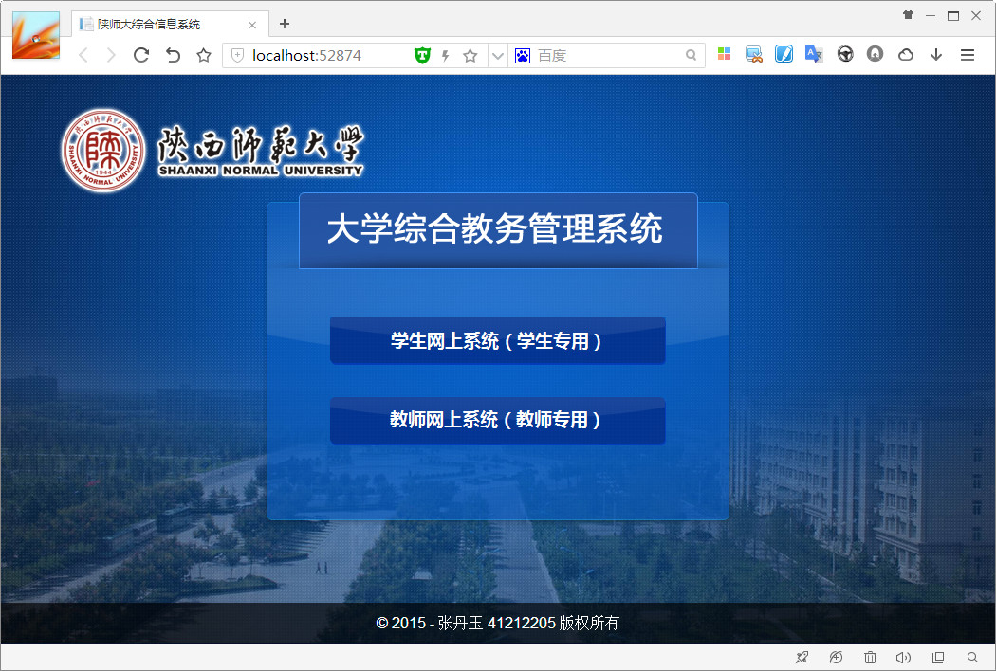

教师通道登录页面
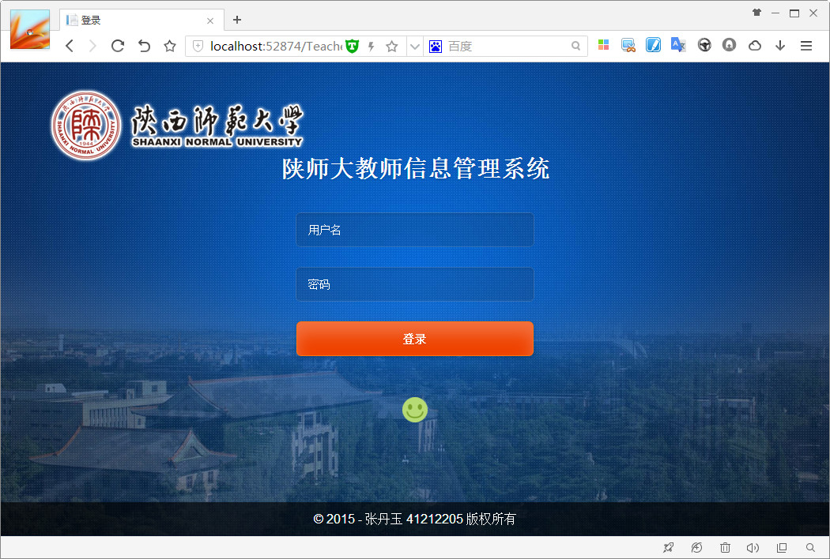
教师信息管理系统首页
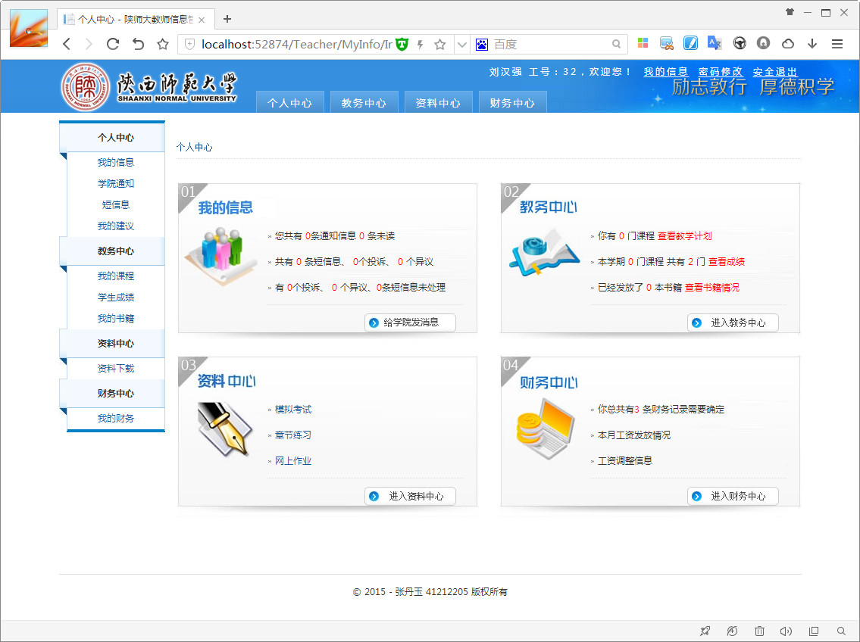

个人信息
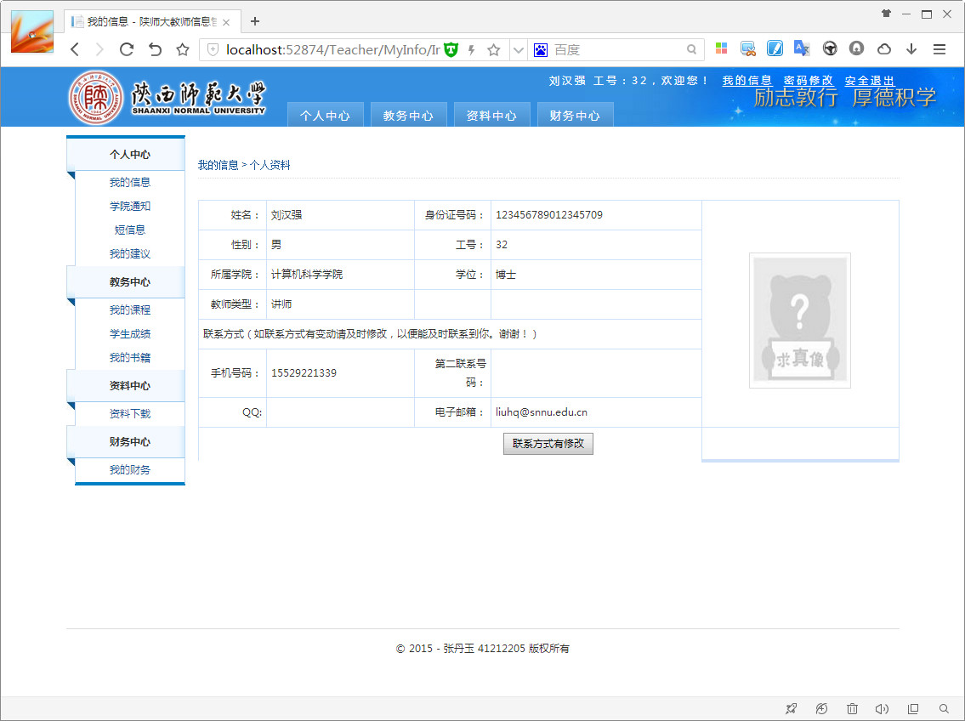

短消息
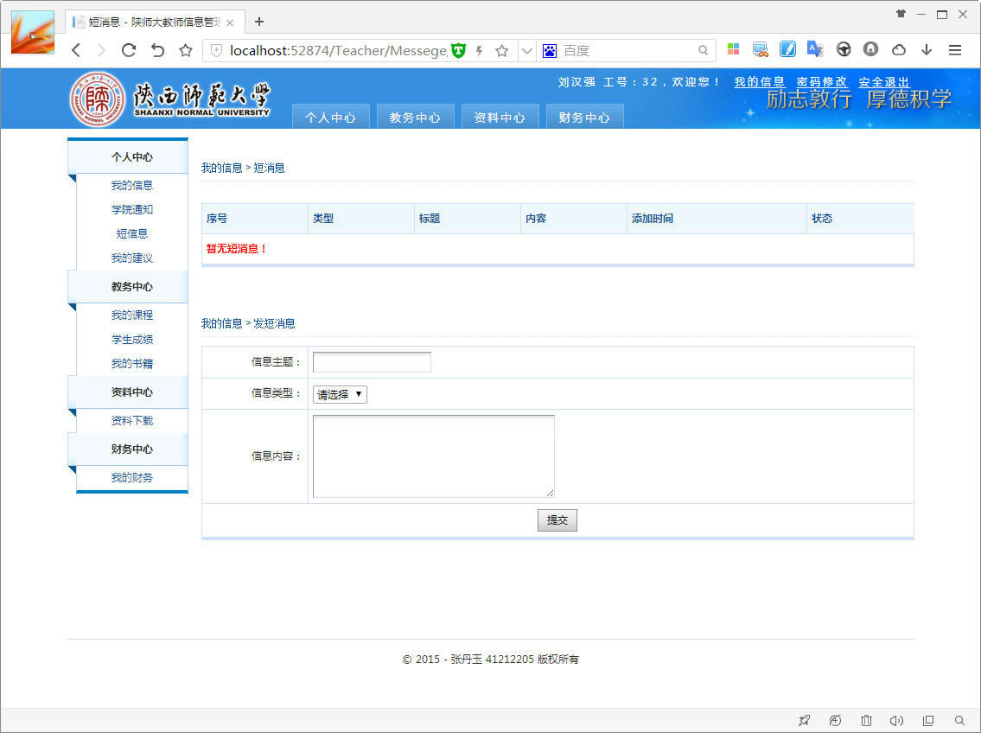

讲授课程
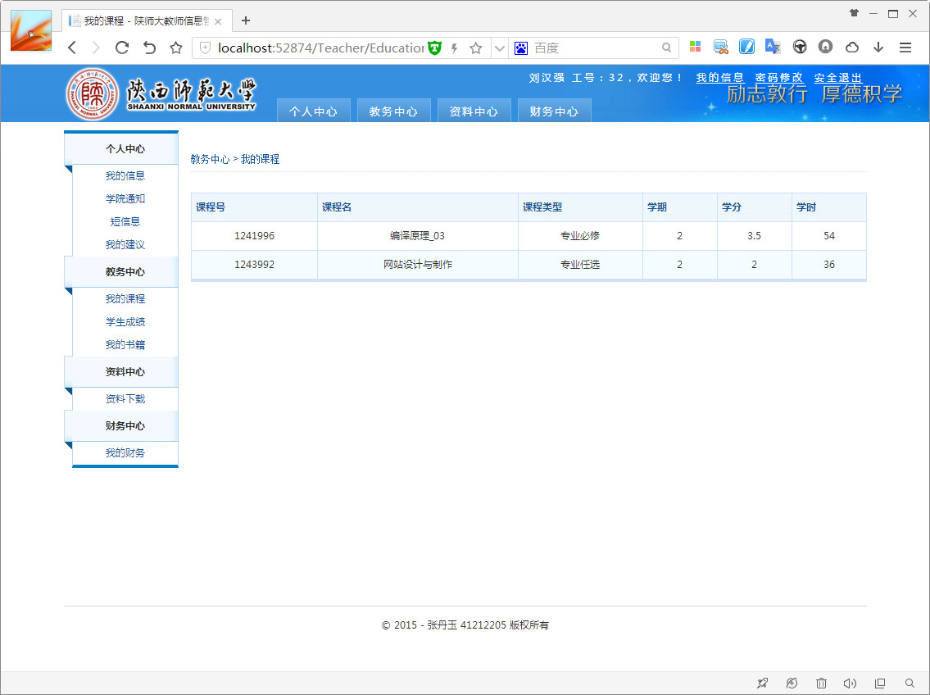

学生成绩
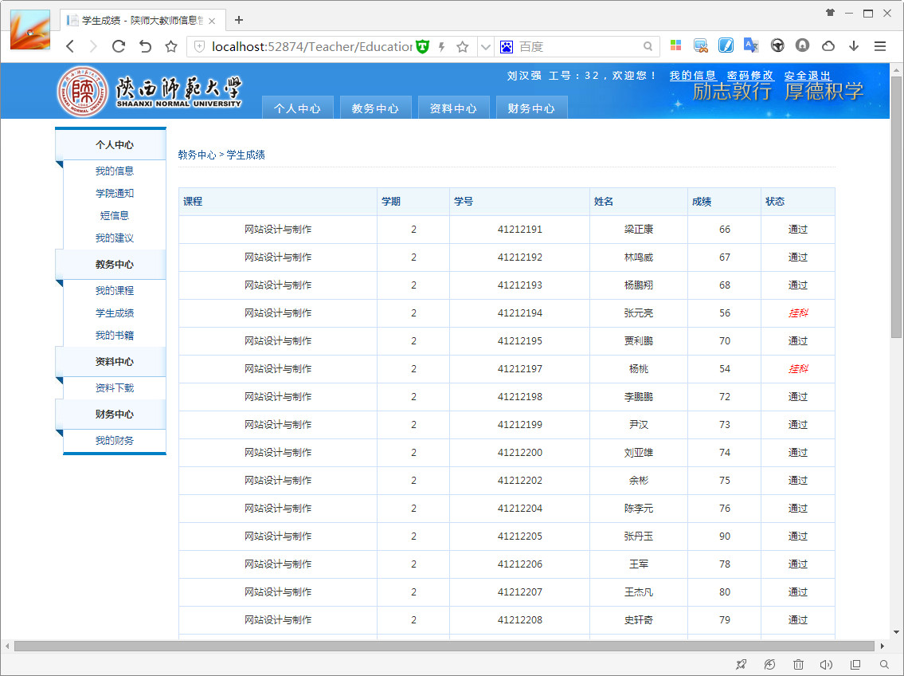

资料下载
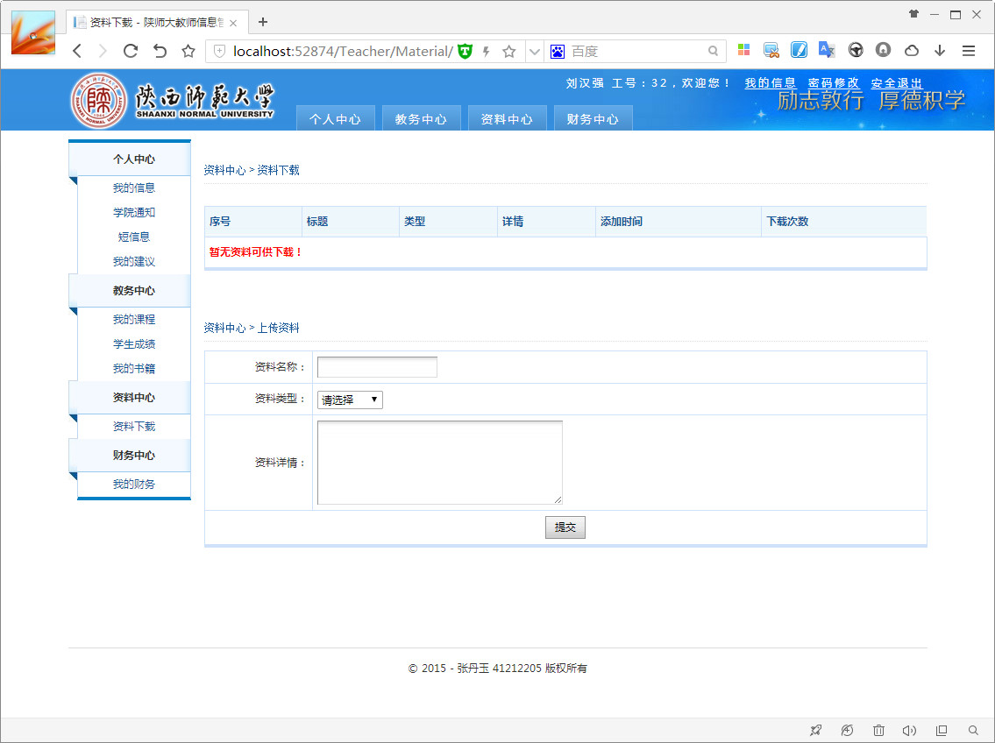

工资信息
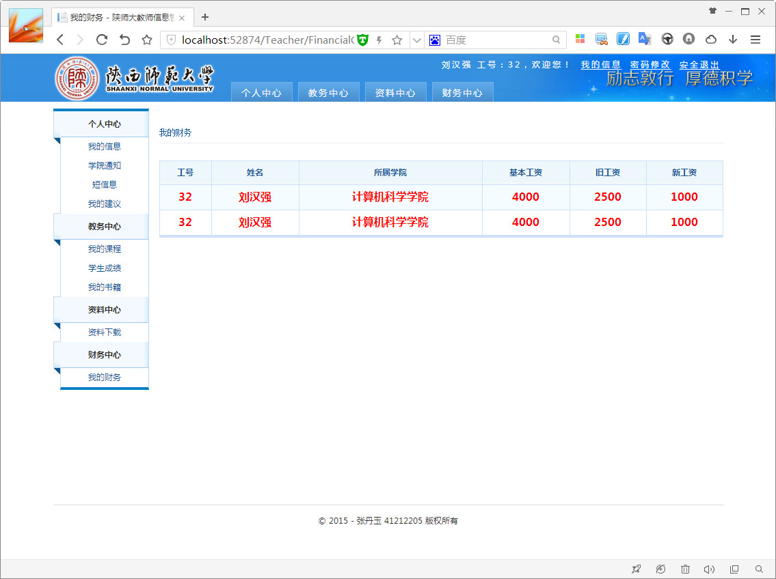

个性化的错误页面
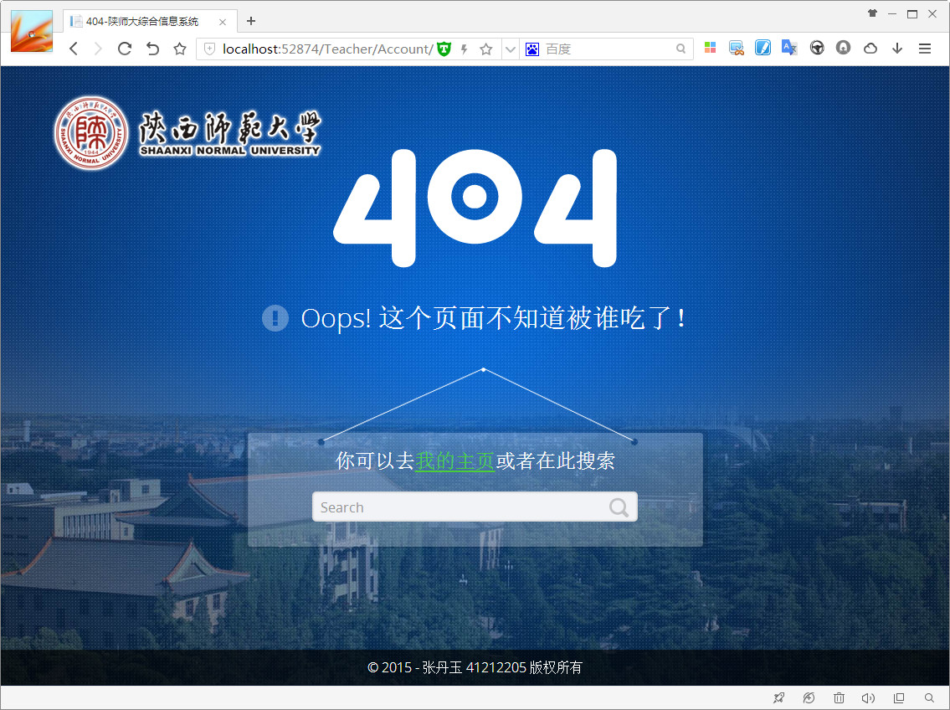

五、总结
在此次课程设计中遇到一些小问题：
该系统的后台数据库采用的是数据库课设的劳动成果，尽管减轻了一定的劳动量，但是该数据库较为复杂，涉及到的数据表众多，导致后期网站开发工作量巨大。
解决方法是重新以简单三层架构 + Asp.Net MVC的方式开发该系统。系统架构清晰，代码复用提高了一个等级，其次在一定程度上增强了系统的可扩展性。
界面设计确实很复杂，所以采用Asp.Net MVC的布局方式进行界面开发，类似于Asp.Net Webform的母版页。Asp.Net MVC不用拖Webform的控件，而是采用div+css设计布局，极大地提高了界面设计的灵活性和用户体验。但同时对我的网页设计也有很高的要求。

